Muhammad Tayyab
Student ID 22092067

Code Git hub Repo https://github.com/tayyabjamil/Assignment-2-ADS-Report.git

Population Dynamics, Greenhouse Gas Emissions, and Economic Factors: A Comparative Analysis of India and China's Growth from 1961 to 2020

China and India increasing population directly contributes to a rise in greenhouse gas emissions as you can see in below graphs. The expanding populace drives greater energy demand, industrial activities, and resource consumption, amplifying the overall environmental impact and emphasizing the need for sustainable practices to address emissions challenges.
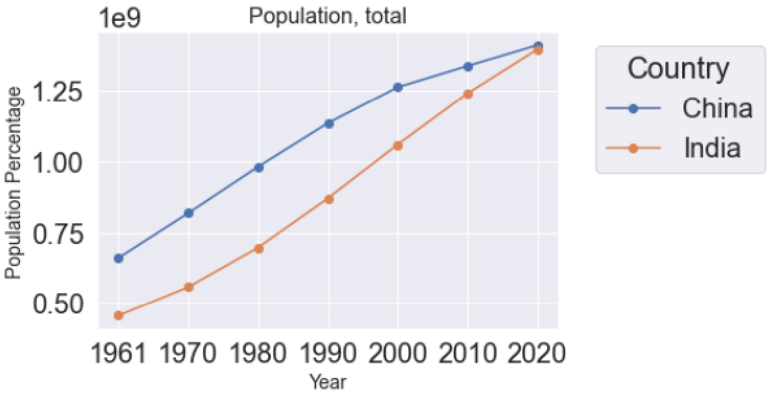
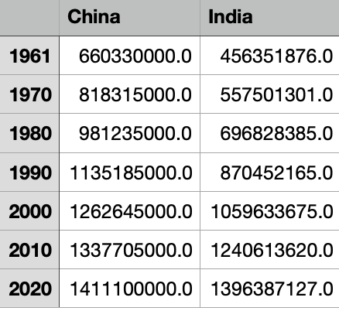
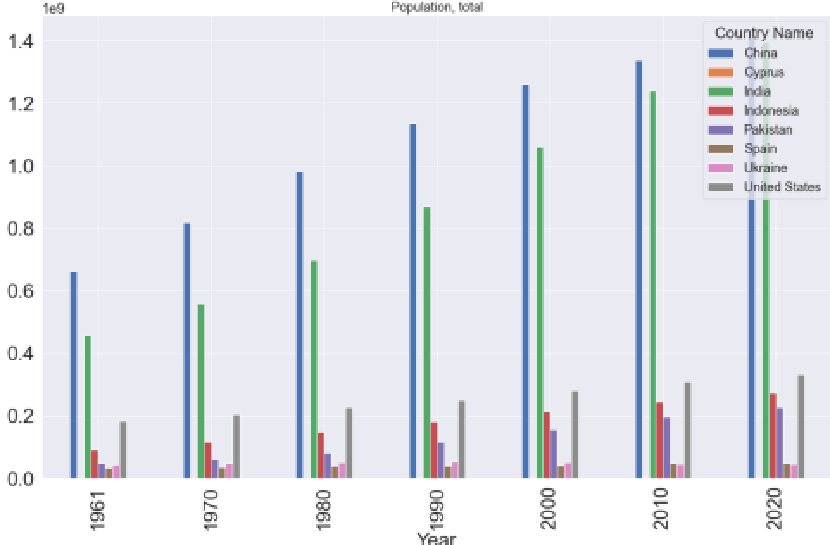
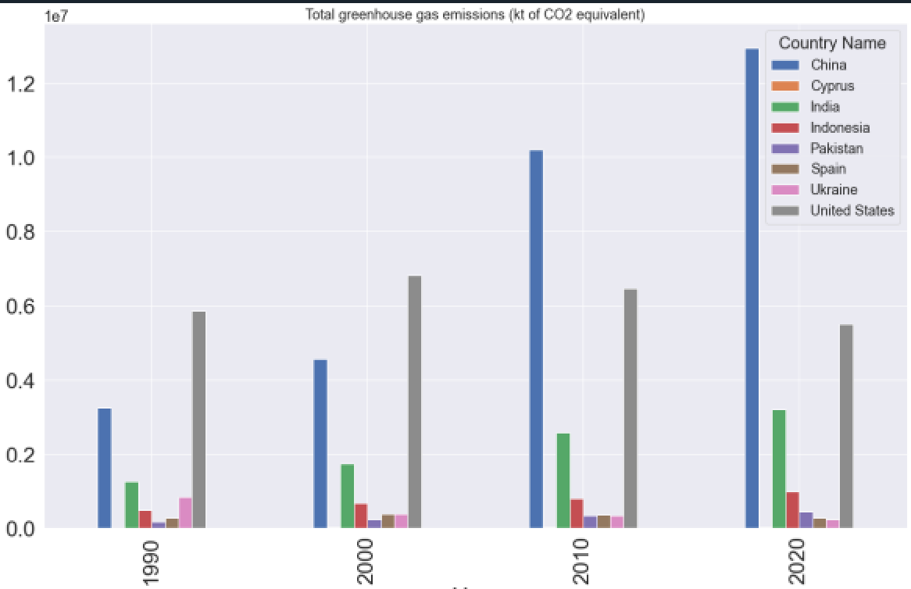
The graph vividly illustrates the remarkable and consistent population growth in both India and China from 1961 to 2020. The upward trajectory reflects a sustained pattern of demographic expansion in these two populous nations. The steep and steady incline underscores the magnitude of their populations, signifying the challenges and opportunities associated with managing such extensive demographic changes over the past six decades. This visual representation emphasizes the enduring trend of rapid population growth in both India and China throughout this period.

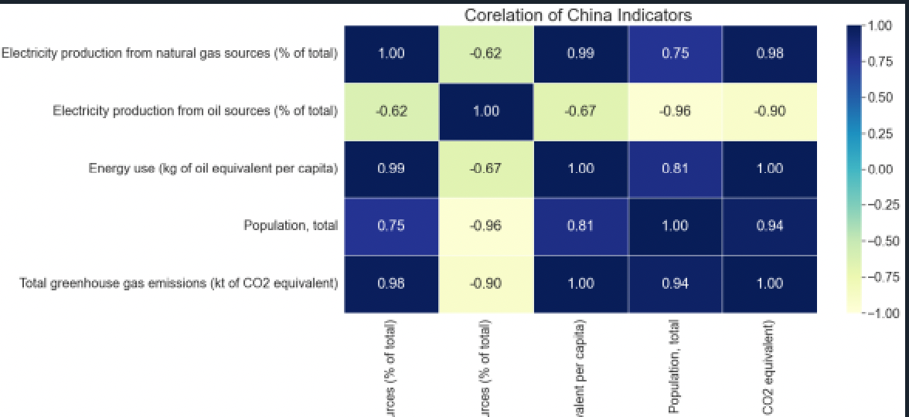
The relationship between the increase in greenhouse gas emissions and the rise in per capita energy use in China is positive. In other words, as per capita energy use increases, there is a corresponding increase in greenhouse gas emissions. This positive correlation indicates that the level of energy consumption on an individual basis is associated with a higher output of greenhouse gases, often stemming from the combustion of fossil fuels like coal .

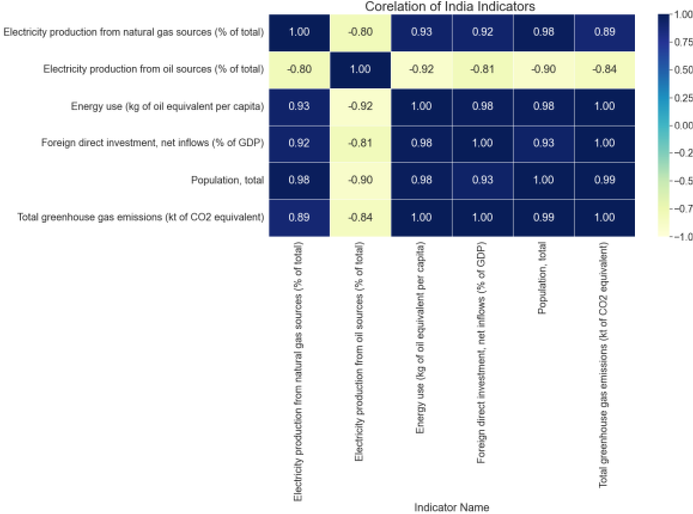
In India, there is a clear and direct relationship between greenhouse gas emissions and foreign direct investment (FDI). As the level of foreign direct investment increases, so does the country's greenhouse gas emissions. This correlation suggests that economic activities driven by foreign investment contribute significantly to India's overall carbon footprint. Understanding and addressing this link is crucial for developing sustainable strategies that balance economic growth with environmental considerations in India's pursuit of long-term development goals.

